Chapter 02.03

Differentiation of Discrete Functions

After reading this chapter, you should be able to:

- find approximate values of the first derivative of functions that are given at discrete data points, and
- use Lagrange polynomial interpolation to find derivatives of discrete functions.

To find the derivatives of functions that are given at discrete points, several methods are available. Although these methods are mainly used when the data is spaced unequally, they can be used for data that is spaced equally as well.

Forward Difference Approximation of the First Derivative
We know
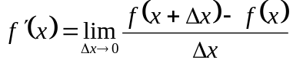
For a finite ,
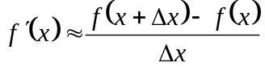
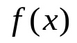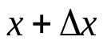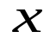
Figure 1 Graphical representation of forward difference approximation of first derivative.

So given 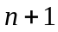 data points 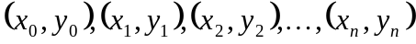, the value of 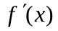 for 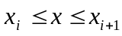, 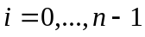, is given by
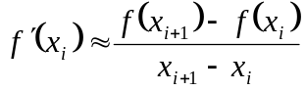

Example 1 easy
The upward velocity of a rocket is given as a function of time in Table 1.

Table 1 Velocity as a function of time.
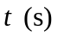 | 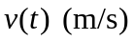
0 | 0
10 | 227.04
15 | 362.78
20 | 517.35
22.5 | 602.97
30 | 901.67

Using forward divided difference, find the acceleration of the rocket at 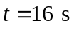.

Solution
To find the acceleration at , we need to choose the two values of velocity closest to , that also bracket to evaluate it. The two points are 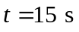 and 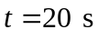

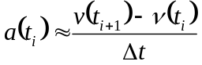
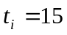
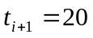
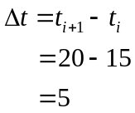
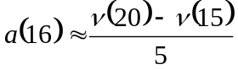
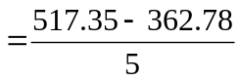
= 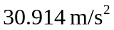

Direct Fit Polynomials
In this method, given data points , one can fit a 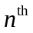 order polynomial given by
To find the first derivative,
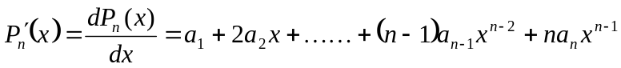
Similarly, other derivatives can also be found.

Example 2
The upward velocity of a rocket is given as a function of time in Table 2.

Table 2 Velocity as a function of time.
0 | 0
10 | 227.04
15 | 362.78
20 | 517.35
22.5 | 602.97
30 | 901.67
Using a third order polynomial interpolant for velocity, find the acceleration of the rocket at 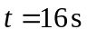.

Solution
For the third order polynomial (also called cubic interpolation), we choose the velocity given by
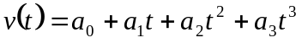
Since we want to find the velocity at , and we are using a third order polynomial, we need to choose the four points closest to 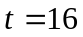 and that also bracket to evaluate it.
The four points are 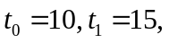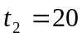 and 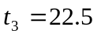.
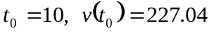
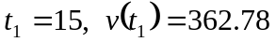
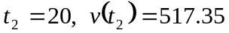
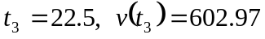
such that
Writing the four equations in matrix form, we have
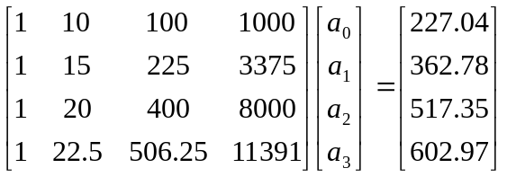

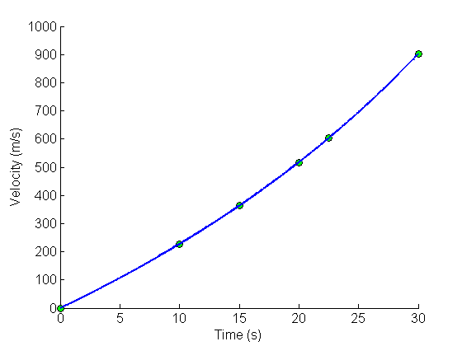
Figure 2 Graph of upward velocity of the rocket vs. time.

Solving the above four equations gives
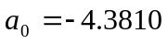
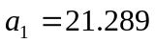
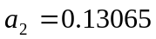
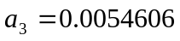
Hence
The acceleration at is given by
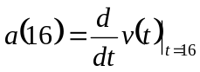
Given that ,
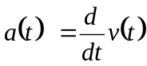
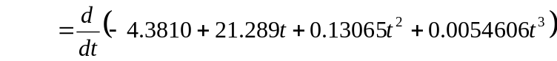
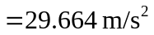

Lagrange Polynomial
In this method, given 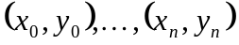, one can fit a 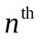 order Lagrangian polynomial given by
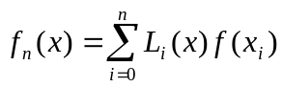
where in 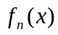 stands for the 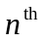 order polynomial that approximates the function  and
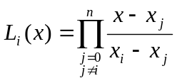
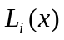 is a weighting function that includes a product of 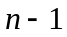 terms with terms of 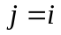 omitted.
Then to find the first derivative, one can differentiate 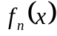 once, and so on for other derivatives.
For example, the second order Lagrange polynomial passing through 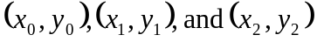 is

Differentiating the above equation gives

Differentiating again would give the second derivative as

Example 3 (copy)
The upward velocity of a rocket is given as a function of time in Table 3.

Table 3 Velocity as a function of time.
0 | 0
10 | 227.04
15 | 362.78
20 | 517.35
22.5 | 602.97
30 | 901.67

Determine the value of the acceleration at 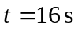 using second order Lagrangian polynomial interpolation for velocity.

Solution
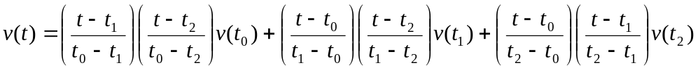
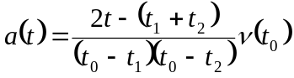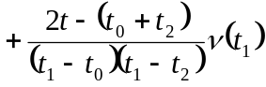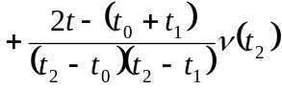

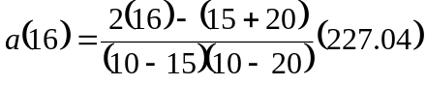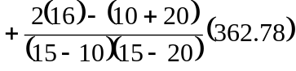
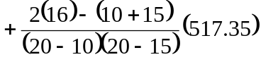
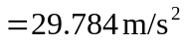

DIFFERENTIATION
Topic | Differentiation of Discrete Functions
Summary | These are textbook notes differentiation of discrete functions
Major | General Engineering
Authors | Autar Kaw, Luke Snyder
Web Site | http://numericalmethods.eng.usf.edu

